# MedServe Installation and Setup

**Note: If you are using a school laptop, you may need an administrator username and password to continue installing the MedServe application.**

# Navigate to the **MedServe_Installer** folder and double-click to open.



1. Double-click on **setup.exe** to start the installation process of the MedServe application.



1. At the “Welcome to the MedServe_Installer Setup Wizard,” choose **Next**.

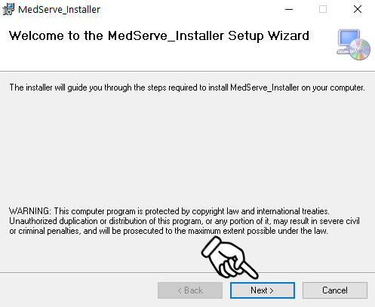

1. Select an installation folder by clicking **Browse**.

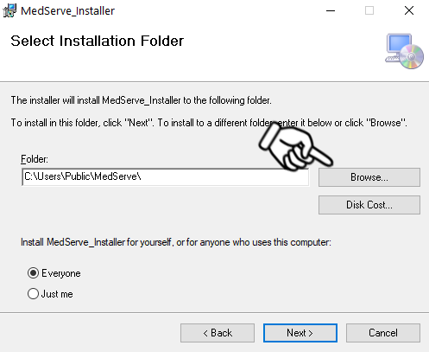

1. Select who can access this application by choosing **Everyone** or **Just me**.

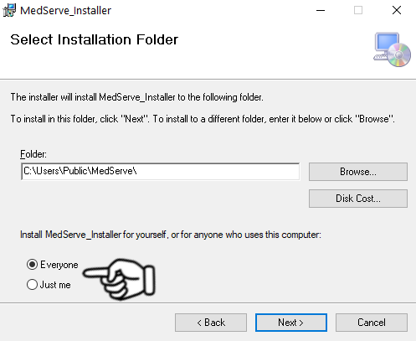

1. Verify the install location and choose **Next**.

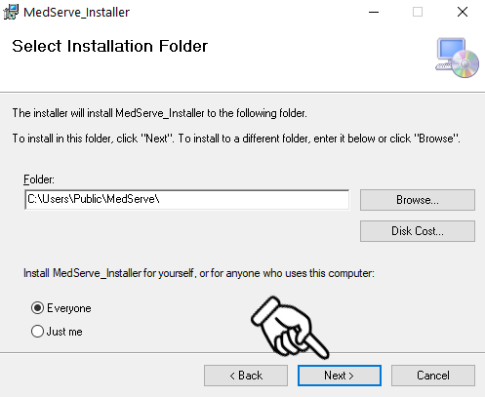

1. Confirm installation by clicking **Next**.

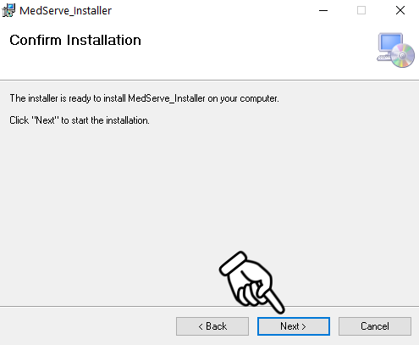

1. Please wait while the **MedServe_Installer** begins the installation process.

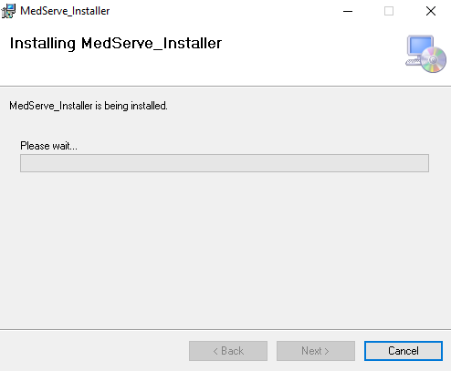

1. Close the **MedServe_Installer** once the installation is complete.

